**Helen Ruffin Reading Bowl**

The Helen Ruffin Reading Bowl is a reading team consisting of ten 4th & 5th grade students who complete with other schools on the district, regional, divisional and state levels. The Helen Ruffin Reading Bowl was the idea of a former media specialist named Helen Ruffin. She thought it would be fun for students in grades 4-12 to get together with other students and have a competition on how well they knew the books they read.

The last few years we have been incredibly successful winning at the district, regional and divisional levels and then the last two years we won the state championship last year (2021) and tied with a school in Valdosta for the State Championship in 2020 because the final competition was cancelled because of Covid-19!!

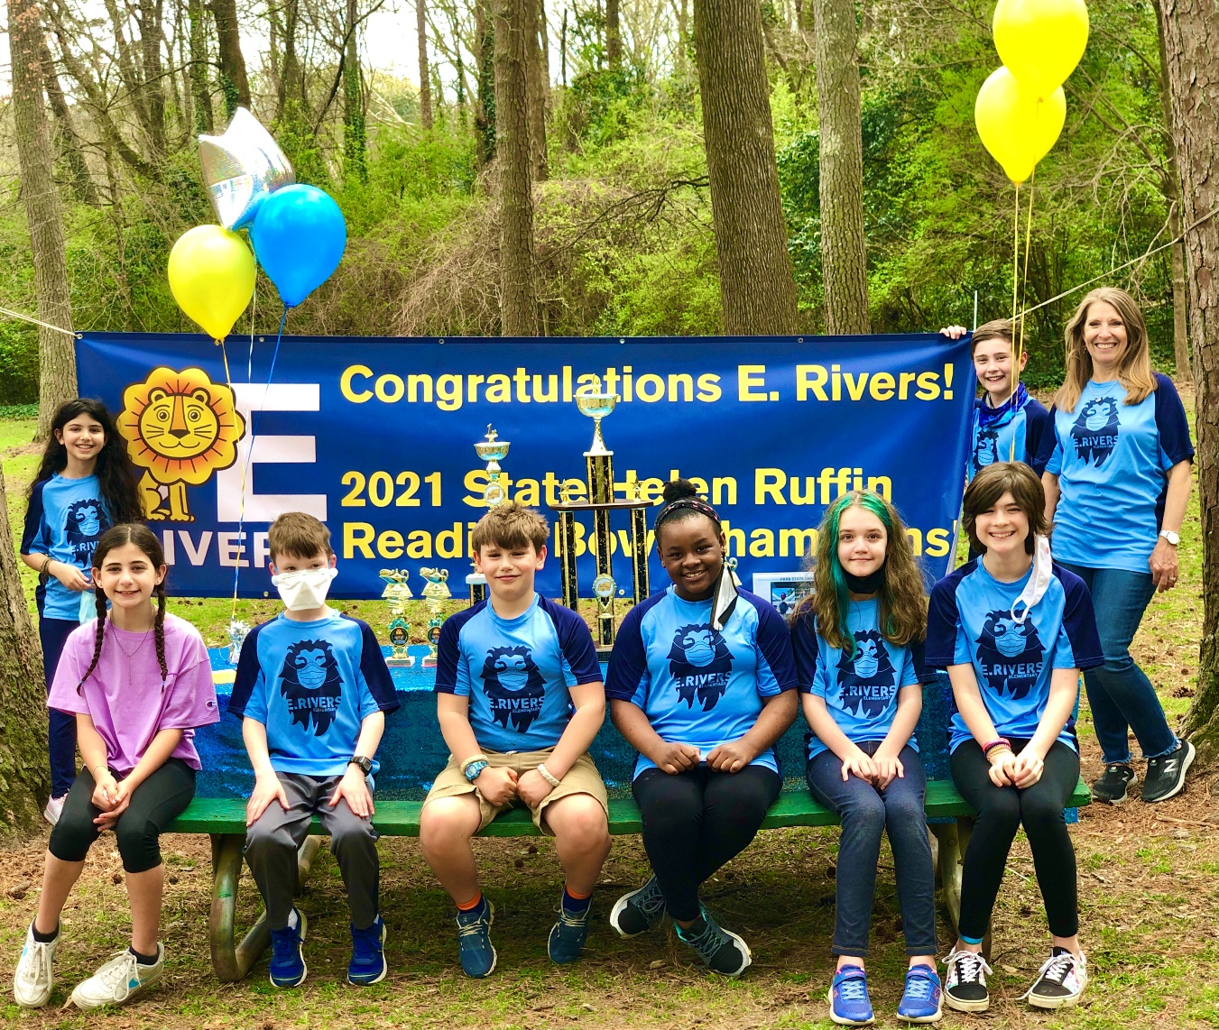We are hoping to have similar success this coming year!